Octagonal Cupola
# Source: AI Source: Provided by: [Data Path: Persons Table -> ID Column: 1, Name_En Column: Motasem Essam] -> From: [ChatGPT] on [7/25/2026]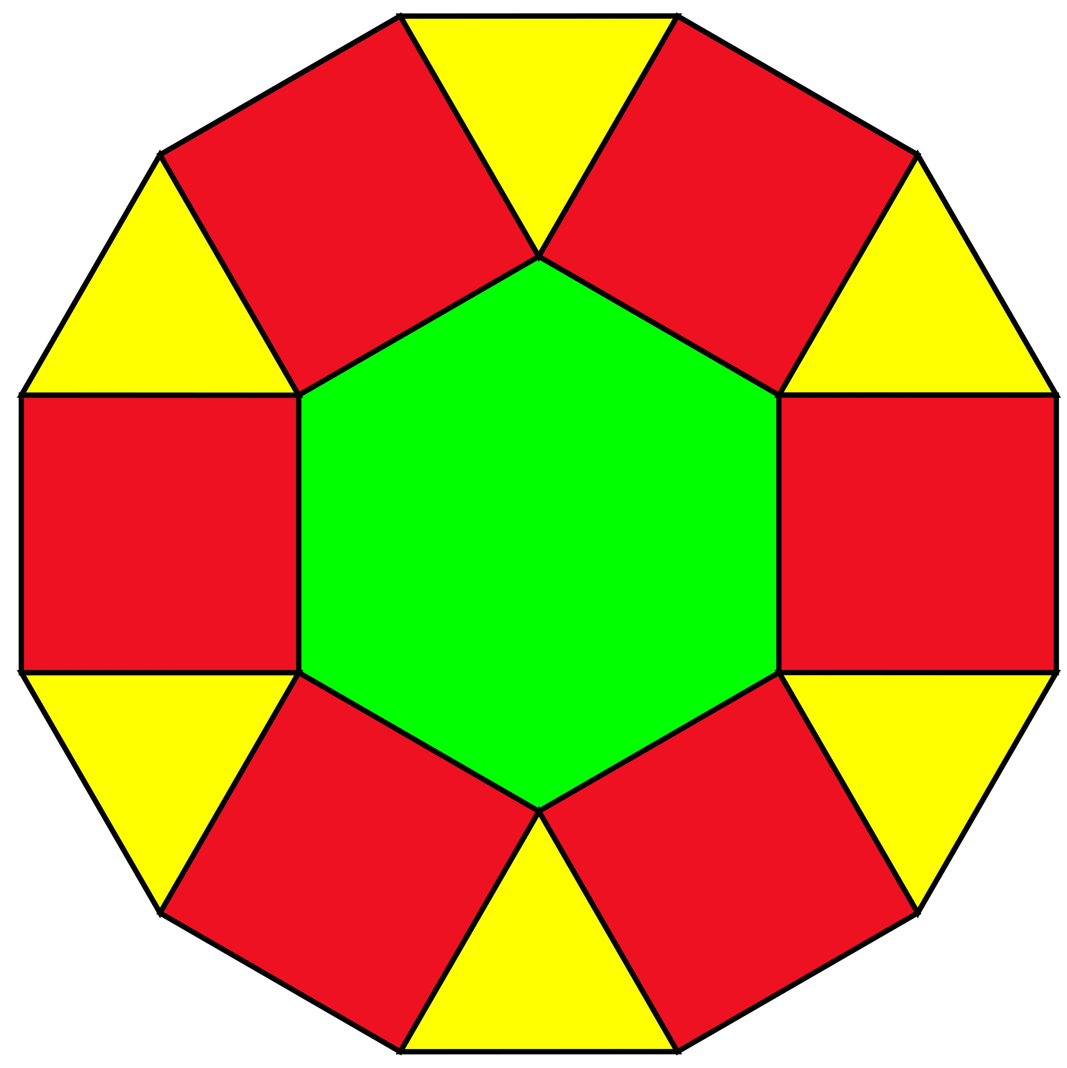

Definition
# Source: AI Source: Provided by: [Data Path: Persons Table -> ID Column: 1, Name_En Column: Motasem Essam] -> From: [ChatGPT] on [7/25/2026]
An Octagonal Cupola is a generalized three-dimensional polyhedron formed by connecting two parallel polygonal bases:
- One octagonal upper base (8 sides).
- One hexadecagonal lower base (16 sides).
- Eight triangular lateral faces.
- Eight rectangular lateral faces.
The triangular and rectangular lateral faces alternate around the solid.
Unlike the triangular, square, and pentagonal cupolas, the generalized Octagonal Cupola is not a Johnson solid.

Geometric Structure
# Source: AI Source: Provided by: [Data Path: Persons Table -> ID Column: 1, Name_En Column: Motasem Essam] -> From: [ChatGPT] on [7/25/2026]
- Upper Base: A regular octagon.
- Lower Base: A regular hexadecagon (16-sided polygon).
- Lateral Faces: Sixteen faces arranged alternately:
- 8 isosceles triangles.
- 8 rectangles.
- Arrangement: The octagonal upper base is positioned above the hexadecagonal lower base, with alternating triangular and rectangular faces connecting their edges.
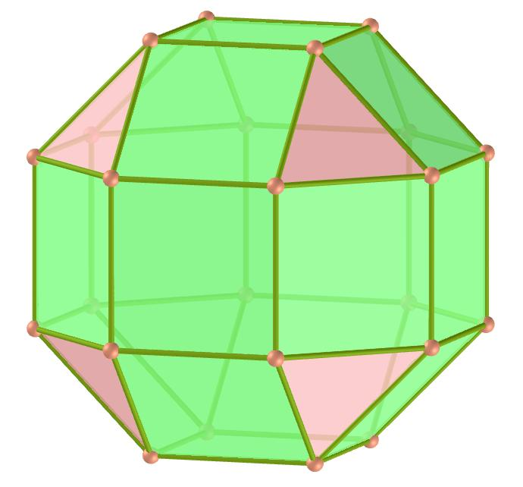

Face Composition
# Source: AI Source: Provided by: [Data Path: Persons Table -> ID Column: 1, Name_En Column: Motasem Essam] -> From: [ChatGPT] on [7/25/2026]
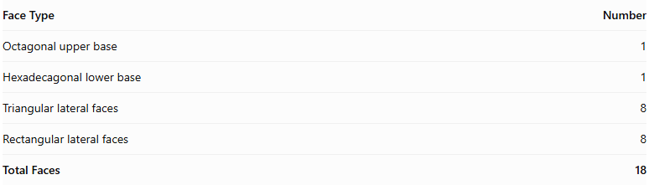
Face Type | Number
Octagonal upper base | 1
Hexadecagonal lower base | 1
Triangular lateral faces | 8
Rectangular lateral faces | 8
Total Faces | 18

Mathematical Properties
# Source: AI Source: Provided by: [Data Path: Persons Table -> ID Column: 1, Name_En Column: Motasem Essam] -> From: [ChatGPT] on [7/25/2026]
For an $n$-gonal cupola:
$$F=2n+2, E=5n, V=3n$$
For an octagonal cupola, $n=8$:
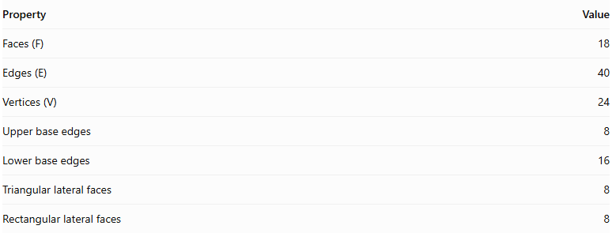
Property | Value
Faces (F) | 18
Edges (E) | 40
Vertices (V) | 24
Upper base edges | 8
Lower base edges | 16
Triangular lateral faces | 8
Rectangular lateral faces | 8
Euler's Formula:
$$V-E+F=2$$
$$24-40+18=2$$
<badge color="success">Euler's formula verified</badge>

Geometric Characteristics
# Source: AI Source: Provided by: [Data Path: Persons Table -> ID Column: 1, Name_En Column: Motasem Essam] -> From: [ChatGPT] on [7/25/2026]
- The octagonal and hexadecagonal bases are parallel.
- The upper octagon has 8 vertices.
- The lower hexadecagon has 16 vertices.
- The lateral faces alternate between triangles and rectangles.
- The solid can have rotational symmetry of order 8 when constructed symmetrically.
- It can be constructed as a convex prismatoid.
- Its lateral faces are not all regular polygons.

Constructing Octagonal Cupola in Solid Geometry

Geometric Instruments Used
# Source: AI Source: Provided by: [Data Path: Persons Table -> ID Column: 1, Name_En Column: Motasem Essam] -> From: [ChatGPT] on [7/25/2026]
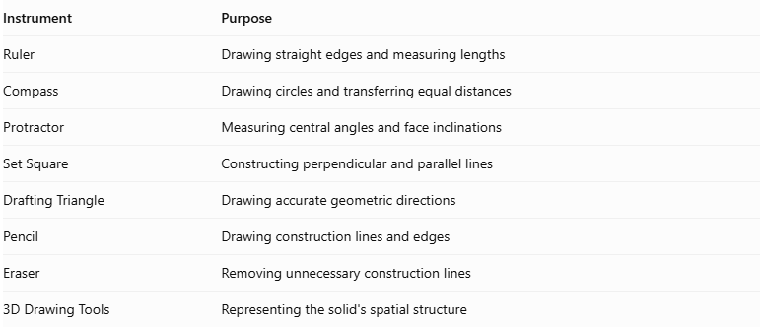
Instrument | Purpose
Ruler | Drawing straight edges and measuring lengths
Compass | Drawing circles and transferring equal distances
Protractor | Measuring central angles and face inclinations
Set Square | Constructing perpendicular and parallel lines
Drafting Triangle | Drawing accurate geometric directions
Pencil | Drawing construction lines and edges
Eraser | Removing unnecessary construction lines
3D Drawing Tools | Representing the solid's spatial structure

Instrument-Based Construction Procedures
# Source: AI Source: Provided by: [Data Path: Persons Table -> ID Column: 1, Name_En Column: Motasem Essam] -> From: [ChatGPT] on [7/25/2026]
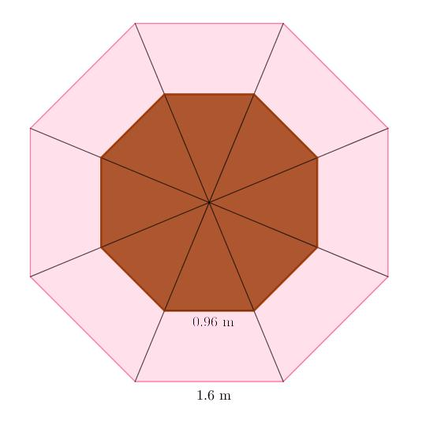

Constructing the Hexadecagonal Base
# Source: AI Source: Provided by: [Data Path: Persons Table -> ID Column: 1, Name_En Column: Motasem Essam] -> From: [ChatGPT] on [7/25/2026]
- Draw a circle using a compass.
- Divide the circle into sixteen equal angular sections using a protractor, with a central angle of:
$$\frac{{360}^{°}}{16}={22.5}^{°}$$
- Mark the sixteen points on the circumference.
- Connect consecutive points using a ruler.
- Complete the regular hexadecagonal base.

Constructing the Octagonal Upper Base
# Source: AI Source: Provided by: [Data Path: Persons Table -> ID Column: 1, Name_En Column: Motasem Essam] -> From: [ChatGPT] on [7/25/2026]
- Draw a regular octagon using a ruler, compass, and protractor as appropriate.
- Position the octagon parallel to the hexadecagonal base.
- Align its eight vertices with the appropriate alternating positions around the lower base.
- Determine the dimensions of the upper base according to the selected cupola geometry.
- Establish the required perpendicular separation between the two base planes.

Constructing the Lateral Faces
# Source: AI Source: Provided by: [Data Path: Persons Table -> ID Column: 1, Name_En Column: Motasem Essam] -> From: [ChatGPT] on [7/25/2026]
- Identify the eight alternating groups of vertices around the hexadecagonal base.
- Connect the appropriate lower-base vertices to the eight vertices of the upper octagon.
- Construct eight quadrilateral lateral faces between the corresponding base edges.
- Construct eight triangular lateral faces between the quadrilateral faces.
- Check that the triangular and quadrilateral faces alternate around the solid.
- Ensure that all shared edges have matching lengths and that the faces form a closed polyhedral surface.

Finalizing the Solid
# Source: AI Source: Provided by: [Data Path: Persons Table -> ID Column: 1, Name_En Column: Motasem Essam] -> From: [ChatGPT] on [7/25/2026]
- Draw the visible edges using continuous lines.
- Represent hidden edges using dashed lines where necessary.
- Check the arrangement of all eighteen faces.
- Verify that the octagonal upper base and hexadecagonal lower base are parallel.
- Erase unnecessary construction lines.
- Complete the three-dimensional representation.
Construction note: This is an instrument-based geometric construction using rulers, compasses, protractors, and geometric relationships. It is not coordinate-based construction. A protractor can be used to mark the required angular divisions for practical drawing.

Key Points
# Source: AI Source: Provided by: [Data Path: Persons Table -> ID Column: 1, Name_En Column: Motasem Essam] -> From: [ChatGPT] on [7/25/2026]
- An Octagonal Cupola has an octagonal upper base and a hexadecagonal lower base.
- It contains 8 triangular and 8 rectangular lateral faces.
- It has 18 faces, 40 edges, and 24 vertices.
- It is a generalized cupola, not one of the 92 Johnson solids.

Classification
# Source: AI Source: Provided by: [Data Path: Persons Table -> ID Column: 1, Name_En Column: Motasem Essam] -> From: [ChatGPT] on [7/25/2026]
Solid Geometry
└── Types of Solids
└── Cupola
└── Types of Cupolas
└── Octagonal Cupola

Conclusion
# Source: AI Source: Provided by: [Data Path: Persons Table -> ID Column: 1, Name_En Column: Motasem Essam] -> From: [ChatGPT] on [7/25/2026]
The Octagonal Cupola is a generalized polyhedron formed by connecting an octagon and a hexadecagon with eight alternating triangular faces and eight rectangular faces. It has 18 faces, 40 edges, and 24 vertices.

